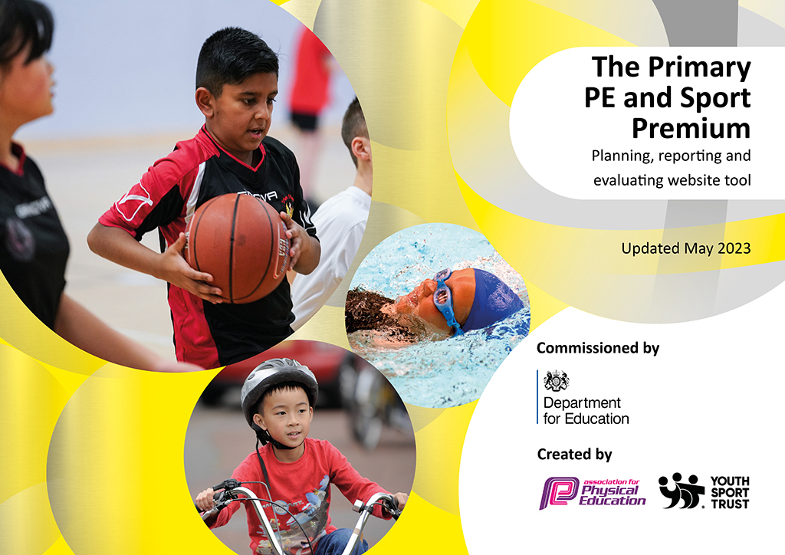
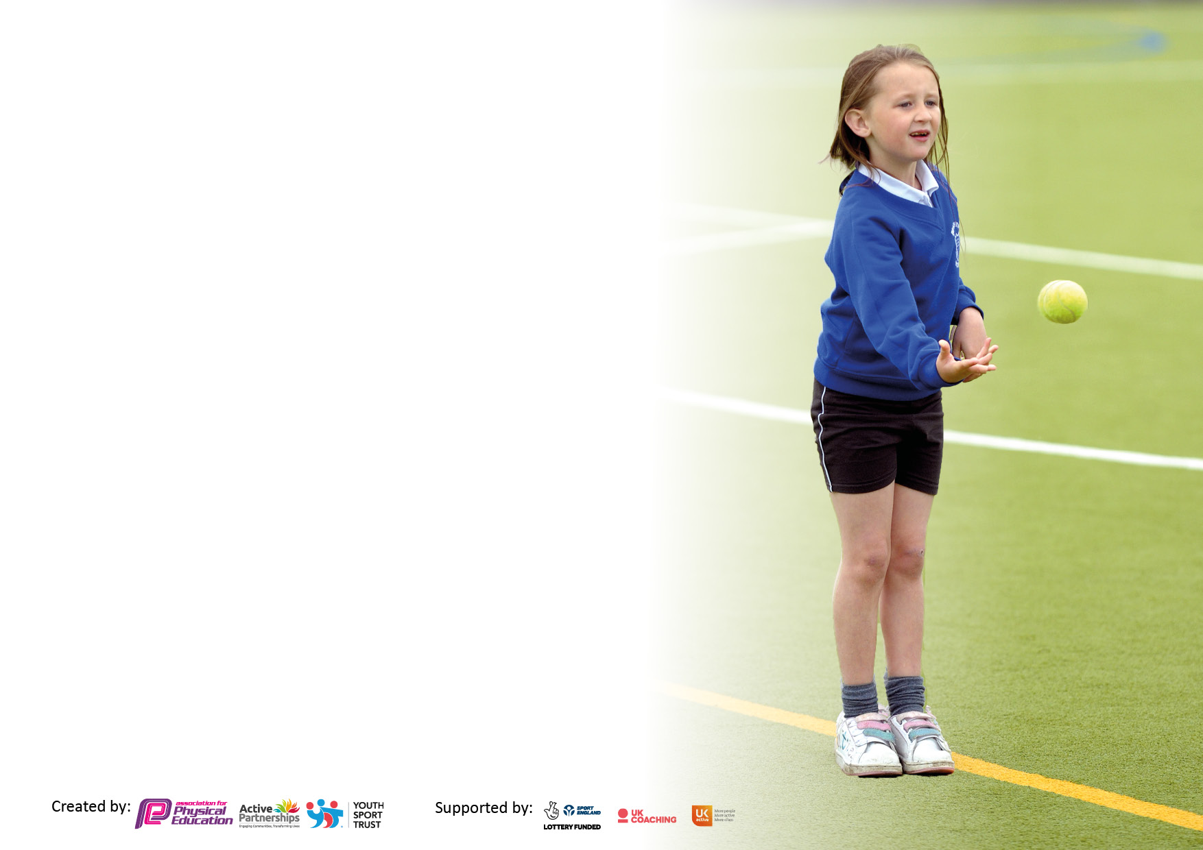

It is important that your grant is used effectively and based on school need. The Education Inspection Framework makes clear there will be a focus on ‘whether leaders and those responsible for governors all understand their respective roles and perform these in a way that enhances the effectiveness of the school’.

Under the Quality of Education Ofsted inspectors consider:
Intent - Curriculum design, coverage and appropriateness
Implementation - Curriculum delivery, Teaching (pedagogy) and Assessment
Impact - Attainment and progress

To assist schools with common transferable language this template has been developed to utilise the same three headings which should make your plans easily transferable between working documents.

Schools must use the funding to make additional and sustainable improvements to the quality of Physical Education, School Sport and Physical Activity (PESSPA) they offer. This means that you should use the Primary PE and sport premium to:

- Develop or add to the PESSPA activities that your school already offer
- Build capacity and capability within the school to ensure that improvements made now will benefit pupils joining the school in future years
- The Primary PE and sport premium should not be used to fund capital spend projects; the school’s budget should fund these.

Pleasevisitgov.ukfortherevisedDfEguidanceincludingthe5keyindicatorsacrosswhichschoolsshoulddemonstrate animprovement.Thisdocumentwillhelpyoutoreviewyourprovisionandtoreportyourspend.DfEencouragesschools to use this template as an effective way of meeting the reporting requirements of the Primary PE and Sport Premium.

We recommend you start by reflecting on the impact of current provision and reviewing the previous spend.

Schools are required to publish details of how they spend this funding, including any under-spend from 2021/2022, as well as on the impact it has on pupils’ PE and sport participation and attainment. All funding must be spent by 31st July 2023.

We recommend regularly updating the table and publishing it on your website throughout the year. This evidences your ongoing self-evaluation of how you are using the funding to secure maximum, sustainable impact. Final copy must be posted on your website by the end of the academic year and no later than the 31st July 2023. To see an example of how to complete the table please click HERE.
Created by: Supported by:

Details with regard to funding
Please complete the table below.

Total amount carried over from 2021/22 | £0
Total amount allocated for 2021/22 | £18,240
How much (if any) do you intend to carry over from this total fund into 2022/23? | £0
Total amount allocated for 2022/23 | £18, 330
Total amount of funding for 2023/23. To be spent and reported on by 31st July 2023. | £ 0
Swimming Data
Please report on your Swimming Data below.

Meeting national curriculum requirements for swimming and water safety.

N.B. Complete this section to your best ability. For example you might have practised safe self-rescue techniques on dry land which you can then transfer to the pool when school swimming restarts.
Due to exceptional circumstances priority should be given to ensuring that pupils can perform safe self rescue even if they do not fully meet the first two requirements of the NC programme of study
What percentage of your current Year 6 cohort swim competently, confidently and proficiently over a distance of at least 25 metres?  N.B. Even though your pupils may swim in another year please report on their attainment on leaving primary school at the end of the summer term 2022.  Please see note above | 86%
What percentage of your current Year 6 cohort use a range of strokes effectively [for example, front crawl, backstroke and breaststroke]?  Please see note above | 73%
What percentage of your current Year 6 cohort perform safe self-rescue in different water-based situations? | 100%
Schools can choose to use the Primary PE and sport premium to provide additional provision for swimming but this must be for activity over and above the national curriculum requirements. Have you used it in this way? | Yes/No

Action Plan and Budget Tracking
Capture your intended annual spend against the 5 key indicators. Clarify the success criteria and evidence of impact that you intend to measure to evaluate for pupils today and for the future.

Academic Year: 2022/23 | Total fund allocated: | Date Updated:
Key indicator 1: The engagement of all pupils in regular physical activity – Chief Medical Officers guidelines recommend that primary school pupils undertake at least 30 minutes of physical activity a day in school |  |  |  | Percentage of total allocation:
 |  |  |  | 10%
Intent | Implementation |  | Impact
Your school focus should be clear what you want the pupils to know and be able to do and about  what they need to learn and to  consolidate through practice: | Make sure your actions to achieve are linked to your intentions: | Funding allocated: | Evidence of impact: what do pupils now know and what can they now do? What has changed?: | Sustainability and suggested next steps:
- To ensure children participate in at least 30 minutes of physical activity per day  - Encourage physical activity during play times and lunch times  - Increase Parental Engagement to ensure that children are active at home as well as at school  - Use of social media to promote opportunities for physical activity | - PE Deep dive  - Questionnaire – find out how active children are in/out of school – for parents/children (Microsoft form)  - Create ‘Change for Life’ clubs for those children who are least active  - Outdoor storage – resources easy to access  - Training for TAs/Lunchtime staff to encourage active play  - PALs training for Year 4/5 children  - Links on school website to clubs/groups out of school | Total: £1919  £200 – PALs/ Ambassadors training (Chorley SSP)  £500 – Sports week – Climbing wall  £269 – Sports week – Golf day  £950 – Chorley SSP – Assessments (Yr2, Yr6, G and T) | - More pupils engaged in being physically active and leading healthy lifestyles  - Children taking ownership of being active – making own choices in free time  - More children achieving age related expectations.  - The field is used more frequently throughout the year for a range of physical activities and at lunch time.  - Children are engaging in physical activity no matter the weather.  - Parents are more aware, engaged and responsive to ensuring their children are physically active and promoting healthy lifestyles - PASTA club and Move and Groove Sessions – KS1, all PE sport shared on Twitter and Dojo.  - Sports week – June 2023 - increase participation in sport, ranging opportunities  - Increased confidence in physical activity with all staff across school - Deep dive monitoring – January 2023  - Children have the confidence to take on sports leadership awards – PALS - PALs training 23.11.22  - School games mark Gold achieved – June 2023  - Active Mile – Linked with World cup – November 2023 – all children took part in this across school – approximately 280 miles run/walked by children in total  - PE Deep dive – lessons observed, pupil interviews, staff audits  - Play time equipment organised into play buckets – KS1, LKS2, UKS2 | From September, Chorley SSP will be running two after school clubs per week covering different sports each half term. As well as this a local dance teacher will be holding dance after school clubs weekly.  Continued focus on making sure children are active during the school day – E.g. Activemaths, staff training – including physical activity in a range of lessons.  PALs training to be used more effectively across playtimes and lunchtimes.  Collecting data from timetables for percentage amount of time children are active.  ‘Physical Fridays’ to be introduced – After the success and positive feedback from the children, look at implementing this into the curriculum every month or two weeks. Opportunity for intra-house competitions across school.
Key indicator 2: The profile of PESSPA being raised across the school as a tool for whole school improvement |  |  |  | Percentage of total allocation:
 |  |  |  | 15%
Intent | Implementation |  | Impact
Your school focus should be clear what you want the pupils to know and be able to do and about  what they need to learn and to  consolidate through practice: | Make sure your actions to achieve are linked to your intentions: | Funding allocated: | Evidence of impact: what do pupils now know and what can they now do? What has changed?: | Sustainability and suggested next steps:
- To strengthen the link between PE and mental wellbeing  - To improve awareness of the benefits of being active and having a healthy lifestyle  - Ensure the profile of PE is raised across the school with up to date and purposeful displays and taking part in local and national initiatives  - Active travel – To advocate leaving the car at home and making active travel an easier option.  - Increase Parental Engagement in children’s physical activities and experiences | - Continue to promote the value of physical activity as a wellbeing tool  - Liaise with CD to discuss links to wellbeing  - Promote healthy lifestyle through assemblies and workshops  - Links with INSPIRE – opportunities out of school/school holidays etc.  - Outside specialists – e.g. Anderton centre – outreach programmes, staff INSET/Training Brockholes, Outdoor elements Burnley  - PE award in assembly  - Accessible storage and grounds for bikes and scooters  - Termly awards for active school travel (e.g. win a bike)  - Bikeability training – Continue training as last year to encourage children to cycle, including: Balance bikes in Reception, level 1 being taught in Year 4 and level 2 to Year 5 children. Enforce the importance to parents of this. Repeat of bike transition ride for Year 6 children with them participating in a longer cycle to their chosen high school.  - Links on school website to clubs/groups out of school  - Use of social media to promote opportunities for physical activity | Total: £2660  £450 – Rock and River subsidy  £800 – Hothersall lodge subsidy  £210 – CSSP – Reception Balance bikes  £60 – CSSP- Learn to ride  £240 - Level 1 and 2 Bikeability – CSSP  £900 – CSSP – Yr6 Bike transition | - Improved Emotional Wellbeing – happy, confident, resilient learners who are competent at facing challenges – Link to ‘Happy Mind’ and Wellbeing Wednesday - My Happy Mind lesson – monthly focus, Wellbeing Wednesday, Yogi group during sports week.  - Children who are more able to work as a team and show consideration for themselves and others  - Improved perseverance – children have skills to persist in spite of difficulties, obstacles, or discouragement.  - Links are made to whole school values and children understand how they impact on their physical as well as mental well-being. (Links made to termly values within lessons, across playtime ect when involved in physical activity.)  - More determined children – with a strong desire to achieve a goal  - Improved behaviour across school with children more able to accept consequences.  - Raised achievement across school and in particular key data groups (YrR, Yr2 and Yr6) – FSM assessment Reception/Year 1, KS1and KS2 CSSP assessments.  - More children celebrating physical activity successes during assembly – PE awards  - Parents more aware, engaged and responsive to ensuring their children are physically active and promoting healthy lifestyles - PASTA club – Chorley SSP – Spring 1, Move and Groove July 2023, Sports week June 2023  - Children choosing to walk/cycle to school – numbers of children doing this increases – Information collected during sports week, prize draw.  - Children enjoy being physically active and understanding the benefits  - Children showing inquisitiveness, creativity and a desire to explore  - Children develop safe risk-taking practices – judging risk and managing risk for themselves - Hothersall Lodge – Oct 22, Rock and River – Nov 22  - Year 3/4 trip to inspire – May 23  - Bikeability – YrR Balance bikes, Yr 4 – Learn to ride/ Level 1 – Autumn term, Yr5 – Level 2 – Autumn term, Yr6 Bike transition – July 23 – Summer term  - Equal Access survey completed – May 23  - KS1 and KS2 Assessments – Chorley SSP  - School games mark Gold achieved – June 2023  - Sports stars workshop – 12 children attended in school (G and T)  - Dance gifted and Talented workshop – 2 pupils put forward from yr6  - Promoting girls in sport – Girls football, Break/Lunch time girls only football sessions  - Achieving success – Year 3/4 girls representing Chorley at Lancashire School Games.  - Health Check questionnaire completed – June 2023 | Outside specialists OAA – Rock and river, Hothersall Lodge – possibility of Yr3/4 being included in this.  Continue to celebrate success in PE/Sports activities in assembly both in and out of school.  Promote sport opportunities outside of school.  Increase number of after school activities involving sport.  Bikeability – continue to provide training for Reception, Yr4 and 5 and also Bike transition for Yr6.  Sports days to be included in sports week and a range of different activities to be made available for children to take part in.  ‘Physical Fridays’ to be introduced – After the success and positive feedback from the children, look at implementing this into the curriculum every month or two weeks.  Archery, Fencing, Judo, Boxing opportunities – after school clubs.  Continue to promote sport and physical activity opportunities on dojo and twitter.  Share with parents information about sports and activity opportunities in the community – CSSP, Chorley FC, Chorley council etc.

Key indicator 3: Increased confidence, knowledge and skills of all staff in teaching PE and sport |  |  |  | Percentage of total allocation:
 |  |  |  | 19%
Intent | Implementation |  | Impact
Your school focus should be clear | Make sure your actions to | Funding | Evidence of impact: what do | Sustainability and suggested
what you want the pupils to know | achieve are linked to your | allocated: | pupils now know and what | next steps:
and be able to do and about | intentions: |  | can they now do? What has
what they need to learn and to |  |  | changed?:
consolidate through practice:
- To provide opportunities for CPD and ensure that staff are skilled in regards to different areas of teaching PE.  - PE subject leader to maintain links with Chorley CSSP in order to be up to date in her subject knowledge as well as being aware of national initiatives and updates.  - CP to continue to work with Chorley SSP and also CHIP cluster to develop knowledge and establish links. | - Chorley SSP – sharing lessons alongside teacher developing teachers knowledge and understanding – range of experiences based on teacher feedback in questionnaires from last year.  - Training for TAs/Lunchtime staff to encourage active play  - CPD that builds staff confidence in delivering cross-curricular outdoor lessons or activities – INSET/Team building day (Anderton Centre etc.)  - CPD for PE assessment – Looking at how to make this more manageable and useful. Ensuring lessons are having an impact. | Total: £3444  £484 – PE Passport App renewal  £2960 – Chorley SSP – Membership, Leadership and Coaching | - Most staff are confident in using the PE app and have the ability to make purposeful judgements about children in their class - Assessments entered on half termly basis, CP encouraging use of APP for assessments/photos of performance which can be accessed and analysed by subject leader.  - Most staff understand how lesson objectives and aims impact the progression of the children in their class – PE Deep dive - Lesson observations, staff questionnaires.  -Most children in classes are competent and confident physically due to staff knowledge and progression.  - Most children make progress across the school in PE (Some not all)  -Most staff understand the progress of skills across year groups and how to use these for next steps for their children.  -Most staff take ownership of the PE curriculum to plan to meet the needs of their pupils using the AfL cycle.  - PE subject leader cascades information regularly back to staff to keep them up to date - PE Deep Dive – January 2023, regular staff meetings, PE App, assessments, updates, competitions and events, sports week timetable, after school clubs, CHIP cluster meetings – subject specific.  - Chorley SSP – Weekly lessons on a Monday – range of classes – staff are supported in their CPD in enabling children to achieve required skills and goals. | Continue to develop teacher’s subject knowledge across all areas of PE, including FMS and higher level skills through shared teaching and good practice.  Ensuring all staff are using the PE Passport app as a means of progression and assessment.  Lessons are adapted and differentiated using the STTEP process (Space, Time, Task, Equipment, People)  Making sure assessment is useful, meaningful and accurate to ensure progression is evident across the whole school.  PE subject leader to continue to be supported by Chorley SSP and cluster school and to attend any relevant training.  Children’s skill level and proficiency is developed and improved in line with other local schools.
Key indicator 4: Broader experience of a range of sports and activities offered to all pupils |  |  |  | Percentage of total allocation:
 |  |  |  | 45%
Intent | Implementation |  | Impact
Your school focus should be clear | Make sure your actions to | Funding | Evidence of impact: what do | Sustainability and suggested
what you want the pupils to know | achieve are linked to your | allocated: | pupils now know and what | next steps:
and be able to do and about | intentions: |  | can they now do? What has
what they need to learn and to |  |  | changed?:
consolidate through practice:
- To develop a curriculum that allows all children to be successful across a wide range of activities and experiences.  - Increase Parental Engagement in children’s physical activities and experiences  - To ensure a greater percentage of children leave Year 6 having achieved end of Key stage expectations for swimming.  - Smaller class sizes attending swim sessions allowing for more pool time and greater focus by swim teachers. | - Involve the children, through the school council, in shaping PE – Link to Happiness Heroes (CD/LY).  - Expose children to activities and experiences that have not normally been part of the curriculum but can help develop fundamental skills.(Through Chorley SSP or other outside groups/clubs – e.g. sports week, Judo after school club).  - Complete another child’s voice questionnaire regarding feelings towards PE – look at different year groups in particular KS1.  - Ensure that lessons are differentiated appropriately to ensure children can access them at their level, and that progression through skills is evident.  - Links on school website to clubs/groups out of school  - Giving children more opportunity for competitive sport outside of school  - Use of social media to promote opportunities for physical activity  - Year 5 and 6 children, who are still not confident swimmers, are identified and attend top-up swimming sessions from September – July | Total: £8207  £8207 - Top-up Swimming (yr5/6) | - PE provision meets the needs of the children in the school and is easily accessible.  - Community links are established for particular sports and these are available for parents to access on the website - Chorley SSP half term clubs shared on dojo/twitter, Lancashire Cricket fliers – February 23, Chorley Football – Jan 22 and Half term clubs.  - Children demonstrate a wide range of skills enabling them to engage with a range of different sports and activities - Wider range of sports being taught in class, Judo education Autumn term  - Children know how the skills that they have learnt transfer over a wide range of areas.  - Children are integral to the development of a PE curriculum and have a voice - PE Deep Dive – January 2023  - Links are established and in place across subjects to promote physical activity - Chorley SSP half term clubs shared on dojo/twitter, Lancashire Cricket fliers – February 23, Chorley Football – Jan 22, May 23, CSSP half term clubs, Learn to ride – shared on twitter and dojo.  - Most parents more aware, engaged and responsive to ensuring their children are physically active and promoting healthy lifestyles – PASTA group, Move and Groove – KS1 has helped to promote this.  - Most lessons meet the needs of all learners - PE Deep Dive – January 2023.  - Increased participation in physical activity in and out of school - Increased compared to last year – 21/22, extra-curricular clubs this year.  - Year 3/4 children taking part in a trip to Inspire – May 23  - Sports week (June 23) – wide range of different sports included – Climbing, Golf, Table tennis etc.  - Equal Access survey completed – May 23  - Promoting girls in sport – Girls football, Break/Lunch time girls only football sessions, #Letgirlsplay, Girls world cup tournament  - Chorley SSP Festivals attended for sports in which children would not normally participate – e.g. orienteering, netball, and hockey.  - Increased number of Year 6 children to be able to swim competently, confidently and proficiently over a distance of at least 25m.  - Children demonstrate a range of strokes effectively  - Children have an understanding of water safety and be able to perform water and land –based rescues in a range of situations.  - All children have confidence in the water.  - More children are taking up swimming as a hobby and continue to develop their stroke and technique outside of school (More evidence of this during this year with a lot more children bringing certificates for swimming/taking part in lessons out of school) | Continue to establish links with local sports clubs – Chorley FC, Alice’s Dance Academy, Jennings Gym, Chorley Panthers Rugby Club, Lancashire Cricket etc.  Outside specialists OAA – Rock and river, Hothersall Lodge – possibility of Yr3/4 being included in this.  Develop role of Sport Ambassadors and leaders to promote different sports in school.  Sports days to be included in sports week and a range of different activities to be made available for children to take part in.  Continue to try to engage parents in encouraging and supporting their children to take part in sports and lead an active lifestyle – Physical Fridays.  Continue to use social media and assemblies to celebrate sporting success.

Key indicator 5: Increased participation in competitive sport |  |  |  | Percentage of total allocation:
 |  |  |  | 11%
Intent | Implementation |  | Impact
Your school focus should be clear | Make sure your actions to | Funding | Evidence of impact: what do | Sustainability and suggested
what you want the pupils to know | achieve are linked to your | allocated: | pupils now know and what | next steps:
and be able to do and about | intentions: |  | can they now do? What has
what they need to learn and to |  |  | changed?:
consolidate through practice:
- School to continue to take part in intra-school competitions and activities throughout the year:  - School to take part in a range of inter-sport competitions and activities  - Staff to become more engaged and support children in participating at different events  - Increase Parental Engagement in children’s physical activities and experiences out of school  - Use of social media to promote opportunities for physical activity | - Sports week  - Sports day  - House competitions  - Chorley SSP – organised events  - Coppull School Games (links with local schools)  - Linking competitions to after school clubs  - staff taking ownership of different areas/sports  - Links on school website to clubs/groups out of school  - Giving children more opportunity for competitive sport outside of school | Total: £2100  £2100 – Chorley SSP – Festivals and Competitions | -Increased numbers of children participating in competitive activity in and out of school - More children sharing certificates in assembly compared to last year – e.g swimming, football, rugby, dance, gymnastics, kick boxing, karate, judo.  - Children attending festivals and enjoying taking part which will change attitudes towards physical activity and in in which children would not normally participate - Chorley SSP dance festival – Feb 23, Gymnastics festival March 23, Netball festival – March 23, Glow dodgeball event – March 2023, Hockey Festival – May 23, Invasion Festival – June 23.  - Multiskills festivals Reception. - Christmas (placed first), Easter and Summer  -Increased success at competitions - 2nd in dance competition, Yr3/4 Girls representing Chorley at School Games – Tri-Golf, gaining higher positions in a range of competitions over the year.  - Children enjoying competing and taking part and understanding the importance of team work - Chorley SSP Competitions participated across a range of sports with a number of different children taking part across school – Events organised termly.  -More children pursuing and taking part in clubs and activities out of school (Some not all)  - Parents sharing in individual and school success of children (Shared in assembly and on Dojo)  - Developing a love of sport that will help lead to lifelong participation in sport.  - Sports days (May 23) and Sports week (June 23) – all children had the opportunity to take part in a range of sports, competing against each other in house teams. | Increase opportunities for after school clubs that link to Chorley SSP competitions.  Continue to take part in a range of Competitions and Festivals with Chorley SSP.  Ensuring teachers include aspects of competition in their lessons.  Establish links with local Coppull primary schools to increase competition across different sports e.g. Football, crocket, rounders etc.  Increase engagement of children in competitions with the support of parents, by highlighting the importance of being part of a team.  Physical Fridays – Engage in competitions on a regular basis.

Signed off by
Head Teacher: | M Chambers
Date: | 17.7.23
Subject Leader: | C. Proctor
Date: | 7.7.23
Governor: | B. Wetton
Date: | 17.7.23

