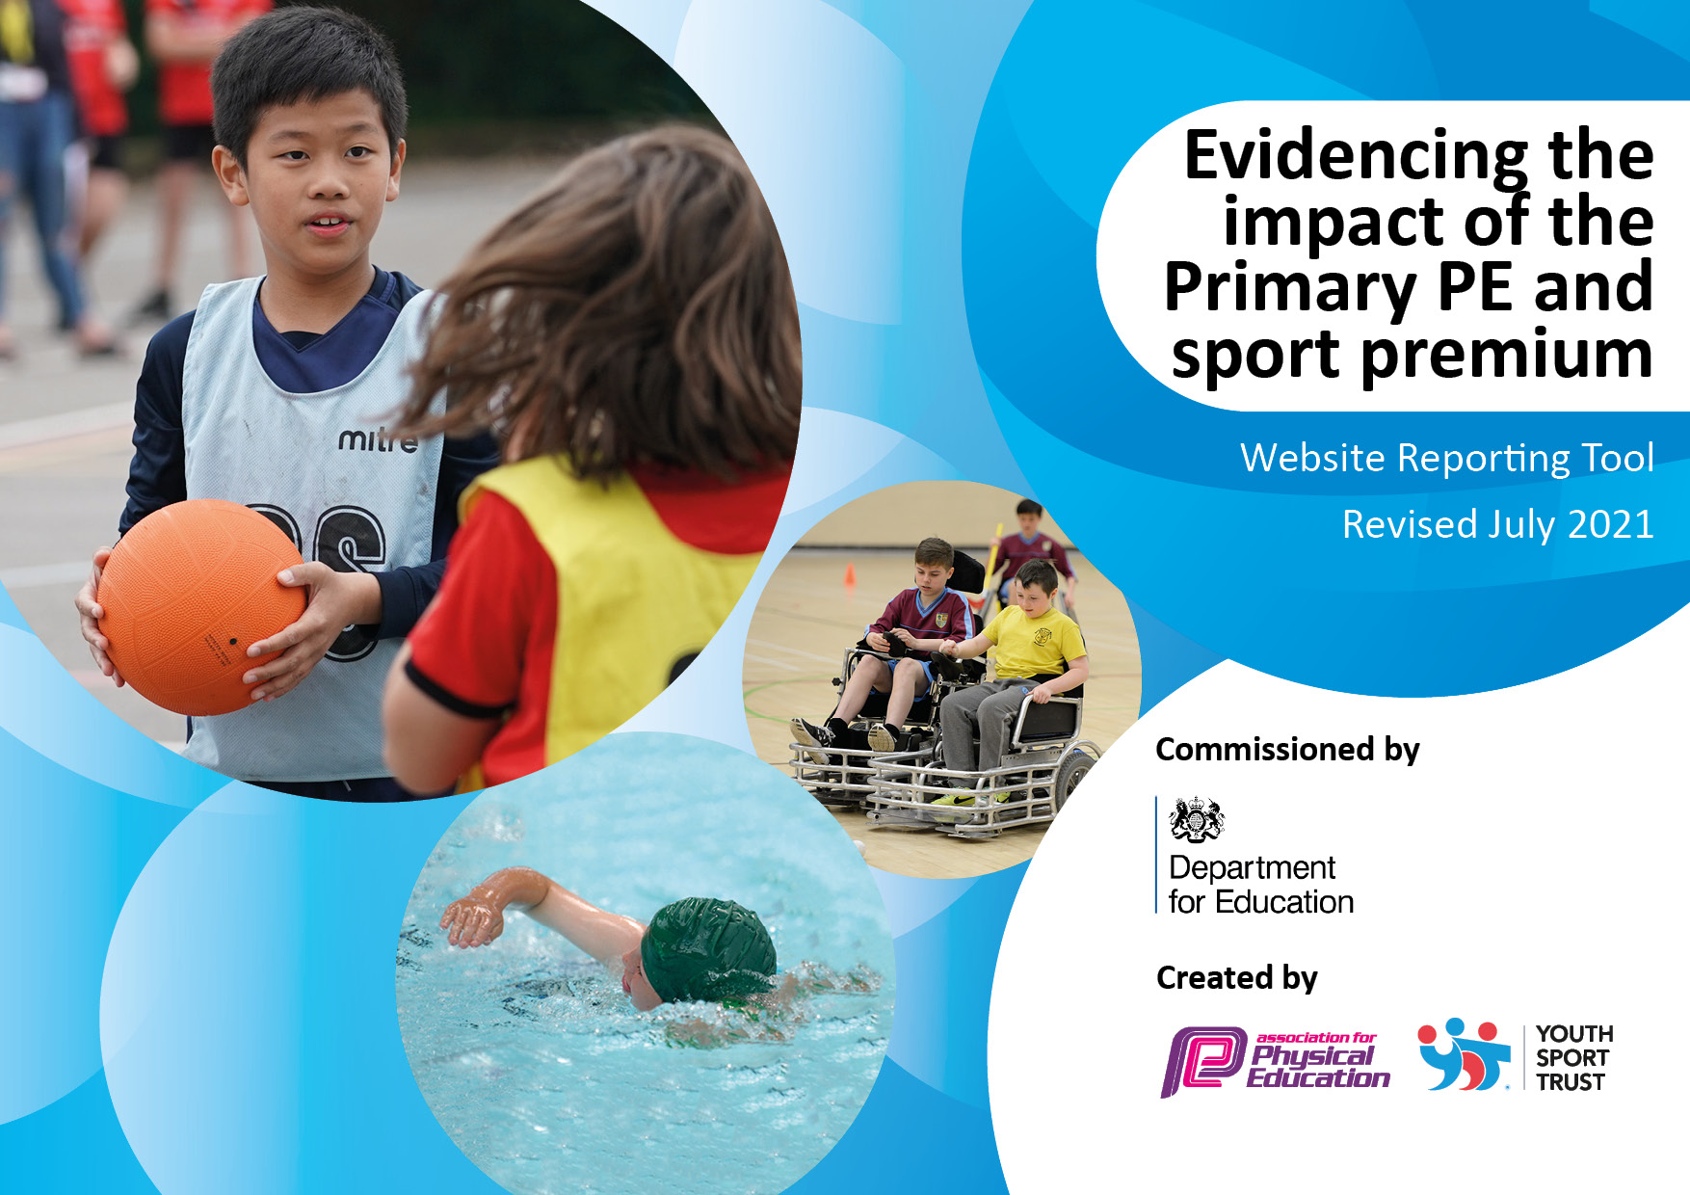
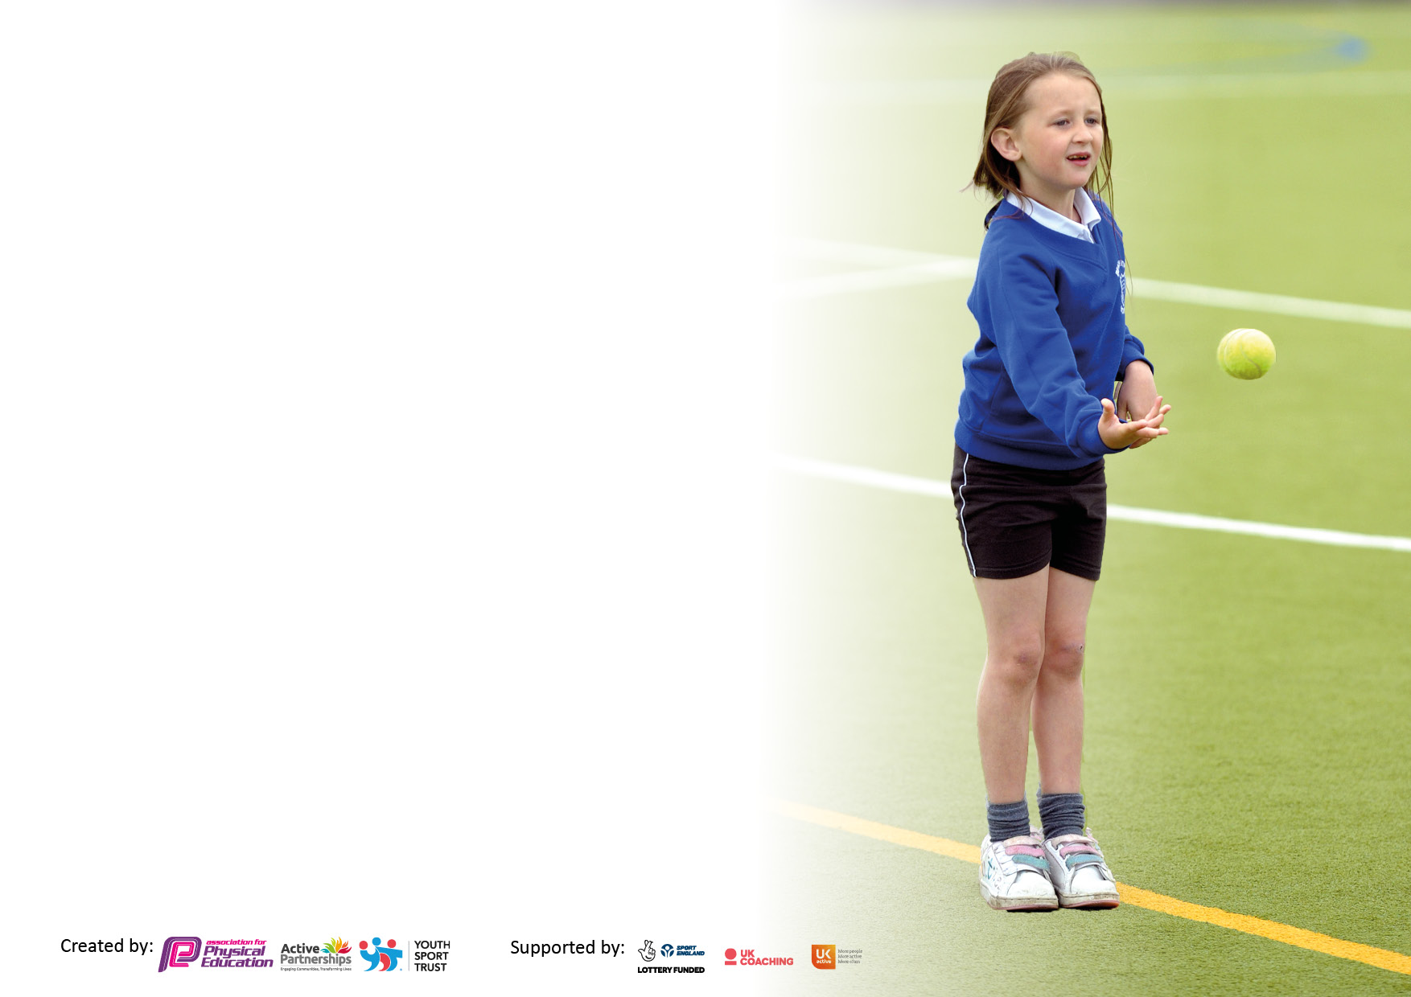

It is important that your grant is used effectively and based on school need. The Education Inspection Framework makes clear there will be a focus on ‘whether leaders and those responsible for governors all understand their respective roles and perform these in a way that enhances the effectiveness of the school’.

Under the Quality of Education Ofsted inspectors consider:
Intent - Curriculum design, coverage and appropriateness
Implementation - Curriculum delivery, Teaching (pedagogy) and Assessment
Impact - Attainment and progress

To assist schools with common transferable language this template has been developed to utilise the same three headings which should make your plans easily transferable between working documents.

Schools must use the funding to make additional and sustainable improvements to the quality of Physical Education, School Sport and Physical Activity (PESSPA) they offer. This means that you should use the Primary PE and sport premium to:

- Develop or add to the PESSPA activities that your school already offer
- Build capacity and capability within the school to ensure that improvements made now will benefit pupils joining the school in future years
- The Primary PE and sport premium should not be used to fund capital spend projects; the school’s budget should fund these.

Pleasevisitgov.ukfortherevisedDfEguidanceincludingthe5keyindicatorsacrosswhichschoolsshoulddemonstrate animprovement.Thisdocumentwillhelpyoutoreviewyourprovisionandtoreportyourspend.DfEencouragesschools to use this template as an effective way of meeting the reporting requirements of the Primary PE and sport premium.

We recommend you start by reflecting on the impact of current provision and reviewing the previous spend.

Schools are required to publish details of how they spend this funding, including any under-spend from 2019/2020, as well as on the impact it has on pupils’ PE and sport participation and attainment. All funding must be spent by 31st July 2022.

We recommend regularly updating the table and publishing it on your website throughout the year. This evidences your ongoing self-evaluation of how you are using the funding to secure maximum, sustainable impact. Final copy must be posted on your website by the end of the academic year and no later than the 31st July 2021. To see an example of how to complete the table please click HERE.
Created by: Supported by:

Details with regard to funding
Please complete the table below.

Total amount carried over from 2019/20 | £11,517
Total amount allocated for 2020/21 | £18,320
How much (if any) do you intend to carry over from this total fund into 2021/22? | £12,485.57
Total amount allocated for 2021/22 | £18,240
Total amount of funding for 2021/22. To be spent and reported on by 31st July 2022. | £30, 725
Swimming Data
Please report on your Swimming Data below.

Meeting national curriculum requirements for swimming and water safety.

N.B. Complete this section to your best ability. For example you might have practised safe self-rescue techniques on dry land which you can then transfer to the pool when school swimming restarts.
Due to exceptional circumstances priority should be given to ensuring that pupils can perform safe self-rescue even if they do not fully meet the first two requirements of the NC programme of study
What percentage of your current Year 6 cohort swim competently, confidently and proficiently over a distance of at least 25 metres?  N.B. Even though your pupils may swim in another year please report on their attainment on leaving primary school at the end of the summer term 2020.  Please see note above | 67%
What percentage of your current Year 6 cohort use a range of strokes effectively [for example, front crawl, backstroke and breaststroke]?  Please see note above | 64%
What percentage of your current Year 6 cohort perform safe self-rescue in different water-based situations? | 87%
Schools can choose to use the Primary PE and sport premium to provide additional provision for swimming but this must be for activity over and above the national curriculum requirements. Have you used it in this way? | Yes/No

Action Plan and Budget Tracking
Capture your intended annual spend against the 5 key indicators. Clarify the success criteria and evidence of impact that you intend to measure to evaluate for pupils today and for the future.

Academic Year: 2020/21 | Total fund allocated: | Date Updated:
Key indicator 1: The engagement of all pupils in regular physical activity – Chief Medical Officers guidelines recommend that primary school pupils undertake at least 30 minutes of physical activity a day in school |  |  |  | Percentage of total allocation:
 |  |  |  | 1%
Intent | Implementation |  | Impact
Your school focus should be clear what you want the pupils to know and be able to do and about  what they need to learn and to  consolidate through practice: | Make sure your actions to achieve are linked to your intentions: | Funding allocated: | Evidence of impact: what do pupils now know and what can they now do? What has changed?: | Sustainability and suggested next steps:
- To ensure children participate in at least 30 minutes of physical activity per day  - Encourage physical activity during play times and lunch times  - Increase Parental Engagement to ensure that children are active at home as well as at school | - Questionnaire – find out how active children are in/out of school – for parents/children  - Create ‘Change for Life’ clubs for those children who are least active  - Audit of physical environment and resources – all weather equipment that children can interact with in different ways  - Making being outdoors in winter more practical (Link to forest schools) – e.g storage, footwear, water proof clothing, shelter.  - Develop outdoor learning area for Forest School sessions and outdoor learning.  - Outdoor storage – resources easy to access  - PALs training for Year 5 children  - Links on school website to clubs/groups out of school  - Use of social media to promote opportunities for physical activity | £318  PALs training = £150  CSSP Fitness after school club - £168 | - More pupils engaged in being physically active and leading healthy lifestyles  - Children taking ownership of being active – playtimes and lunchtimes, increased activity.  - Children are engaging in physical activity no matter the weather.  - Parents are more aware, engaged and responsive to ensuring their children are physically active and promoting healthy lifestyles (Use of social media to promote events activities, e.g. #LetGirlsPlay, School Games Mark Gold, Sports week activities)  - Increased confidence in physical activity with all staff across school (staff questionnaires)  - PALS Training – Chorley SSP - Year 5 - October 29th  - Achieving Active School Games Gold Mark – July 2022  - Fitness After school club – Chorley SSP – Summer 1 (6 weeks) | More after school clubs to be set up from September with a particular focus on health and fitness as well as building FMS.  Continued focus on making sure children are active during the school day – Movement/physical activity timetable.  PALs training to be used more effectively with the children now not being in bubbles.  Training to take place with lunchtime staff and TA to develop playtime games.  Continue to use social media as a tool to promote physical activity and ideas to parents.
Key indicator 2: The profile of PESSPA being raised across the school as a tool for whole school improvement |  |  |  | Percentage of total allocation:
 |  |  |  | 31%
Intent | Implementation |  | Impact
Your school focus should be clear what you want the pupils to know and be able to do and about  what they need to learn and to  consolidate through practice: | Make sure your actions to achieve are linked to your intentions: | Funding allocated: | Evidence of impact: what do pupils now know and what can they now do? What has changed?: | Sustainability and suggested /next steps:
- To strengthen the link between PE and mental wellbeing  - To further develop Forest School  - To improve awareness of the benefits of being active and having a healthy lifestyle  - Ensure the profile of PE is raised across the school with up to date and purposeful displays and taking part in local and national initiatives  - Active travel – To advocate leaving the car at home and making active travel an easier option.  - Increase Parental Engagement in children’s physical activities and experiences | - Continue to promote the value of physical activity as a wellbeing tool  - Liaise with CD to discuss links to wellbeing  - Links with INSPIRE – opportunities out of school/school holidays etc.  - Outside specialists – e.g. Anderton centre – outreach programmes, staff INSET/Training Brockholes, Outdoor elements Burnley  - Identify target groups to take part in a sequence of Forest School sessions each half term/term.  - Ensure Forest School Leader assessment and first aid is completed to ensure best practice and safety.  - Audit resources needed to provide engaging Forest School sessions.  - Seek whole-staff input on what Forest School should look like at Coppull Primary to ensure staff are involved and are aware of the benefits Forest School can have.  - PE award in assembly  - PE based assemblies and focus on upcoming events – Women’s Euros, Commonwealth games etc.  - Promote healthy lifestyle through assemblies and workshops  - Accessible storage and grounds for bikes and scooters  - Bikeability training – Increase the amount of training to place this year including level 1 being taught in Year 4 to encourage children to get on their bikes, as well as introducing a transition ride for Year 6 children that will look at them participating in a longer cycle to their chosen high school.  - Balance Bikes (YrR and Year 1 this year due to Covid19),  - Bikeability – Year 4 Level 1 , Year 5 Level 1 and 2  - Year 6 transition bike ride  - Links on school website to clubs/groups out of school  - Use of social media to promote opportunities for physical activity | £9567  Forest School = £5907  Winmarleigh = £1437  Colour Run = £883  Balance Bikes/Learn to ride/Bikeability/Bike Transition = £1230  Zumba = £160 | - Active learning strategies and outdoor learning initiatives are embedded throughout the school  - Improved Emotional Wellbeing – happy, confident, resilient learners who are competent at facing challenges  - Children who are more able to work as a team and show consideration for themselves and others  - Improved perseverance – children have skills to persist in spite of difficulties, obstacles, or discouragement. (Link to whole school values – PSHE - Resilience)  - More determined children – with a strong desire to achieve a goal  - Improved behaviour across school with children more able to accept consequences.  - More children celebrating physical activity successes during assembly  - Role models of physical activity throughout school  - Parents more aware, engaged and responsive to ensuring their children are physically active and promoting healthy lifestyles (Spar Active mile Challenge – November)  - Children are enjoy being physically active and understanding the benefits  - Children have taken part in Forest school sessions in the autumn and spring term  - Children showing an awareness of and a respect for the natural world around them  - Children showing inquisitiveness, creativity and a desire to explore  - Children develop safe risk-taking practices – judging risk and managing risk for themselves  - Achieving Active School Games Gold Mark – July 2022  - Rock and River – Year 5 – 5th Nov  - Winmarleigh – Year 6 13th-15th Oct  - CP Assembly – 22.9.21 – National Fitness Day, Commonwealth games – 9.3.22, Women’s Euros 12.7.22  - Lancashire Active mile and Active Journey – Wk beg 22.11.21 (Social media)  - Inspire trip – Cedar and Cypress – July 2022  - Social media – Twitter – sharing success in PE/Sports week etc.  - Colour run – Sports Week – June 2022  - Zumba activity – Sports week – June 2022  - Judo taster session – Sports week – June 2022  - Balance bikes – Year R and Year – January 2022  - Bikeability – Year 4 Level 1 – September 2021  - Bikeability – Year 5 – Level 1 and 2 – October 2021  - Year 6 Bike transition ride – July 2022 | Further develop the links with wellbeing team.  Outside specialists to be used – Outdoor education providers, trips, Inspire (Year 4 trip) etc.  PE award in assembly  Continuation of celebrating PE/Sport activity success in assemblies – use of social media and website for this also.  Focus on World cup  Balance bikes – Year R  Learn to Ride – Year 4  Bikeability – Level 1 Yr4  Bikeability – Level 2 – Year 5  Bike Transition – Year 6  Sports week to be planned and organised to include a variety of sports.  Judo after school club – Autumn term – Possibly further after school clubs, e.g. Archery, Fencing (Outside provider)

Key indicator 3: Increased confidence, knowledge and skills of all staff in teaching PE and sport |  |  |  | Percentage of total allocation:
 |  |  |  | 12%
Intent | Implementation |  | Impact
Your school focus should be clear  what you want the pupils to know  and be able to do and about  what they need to learn and to  consolidate through practice: | Make sure your actions to  achieve are linked to your  intentions: | Funding  allocated: | Evidence of impact: what do  pupils now know and what  can they now do? What has  changed?: | Sustainability and suggested
 |  |  |  | next steps:
- To provide opportunities for CPD and ensure that staff are not deskilled with regards to teaching PE.  - To develop the new PE subject leaders knowledge of the curriculum, PE premium and the role of sport in school.  - CP to familiarise herself with new Development Matters curriculum and progression documents for PE | - Chorley SSP – sharing lessons alongside teacher developing teachers knowledge and understanding  - Audit PE provision – staff competency, resources etc. – observation, monitoring assessments, interviews, questionnaires  - CP to work with Chorley SSP and also CHIP cluster to develop knowledge and establish links  - CP to liaise with Chorley SSP/Lancs PE to develop understanding of PE APP and it’s use for tracking and monitoring progression across school. | £3602  PE App = £450  CSSP Leadership = £800  CSSP Lesson Support = £2352 | - Staff are qualified, competent and confident to deliver high quality PE and physical activity opportunities. (OFSTED deep dive questioning and observations)  - Children in classes are competent and confident physically due to staff knowledge and progression. (Lesson observations and staff questionnaires – w/k beg 24.1.22, OFSTED deep dive – questioning children)  - All children make progress across the school in PE (OFSTED deep dive)  - Staff feel comfortable discussing challenges and concerns they have in the teaching of PE (Staff questionnaires – w/k beg 24.1.22, OFSTED deep dive, staff questioning)  - All staff understand the progress of skills across year groups (OFSTED Deep Dive)  - Staff take ownership of the PE curriculum to plan to meet the needs of their pupils. (Observations, OFSTED deep dive)  - PE subject leader is more confident in her role and has the skills and knowledge to move the school forward. (Monitoring week – w/k beg 24.1.22, Cluster meeting – 2.2.22, 15.6.22, PLT days – 6.10.21, 16.5.22, 1:1 Meetings with Daneka – Chorley SSP – 20.6.22, PE conference – Edge Hill – 24.5.22) | Continue to develop teacher’s skills, knowledge and understanding by having a focus on Fundamental Movement skills across school. Building on progression and next steps for individual children.  Developing a PE curriculum that allows a child at Coppull to make progress and have opportunities in sports as well as leading healthy lifestyles.  Further development in the use of assessment that is meaningful and purposeful to staff.  Developing the use of the PE Passport App as a tool for progression.  Subject leader and school staff to continue to work alongside CSSP to develop and improve lessons. Specific teachers to develop confidence in teaching areas of PE showing progression in skills.
Key indicator 4: Broader experience of a range of sports and activities offered to all pupils |  |  |  | Percentage of total allocation:
 |  |  |  | 47%
Intent | Implementation |  | Impact
Your school focus should be clear  what you want the pupils to know  and be able to do and about  what they need to learn and to  consolidate through practice: | Make sure your actions to  achieve are linked to your  intentions: | Funding | Evidence of impact: what do  pupils now know and what can they now do? What has changed? | Sustainability and suggested
 |  | allocated: |  | next steps:
- To develop a curriculum that allows all children to be successful across a wide range of activities and experiences.  - Increase Parental Engagement in children’s physical activities and experiences  - Due to Covid19 having a significant impact on leisure centres, a large number of children have missed swimming sessions and so top-up lessons need to be made available. | - Involve the children, through the school council, in shaping PE.  - Expose children to activities and experiences that have not normally been part of the curriculum but can help develop fundamental skills.(Through Chorley SSP or other outside groups/clubs)  - Complete child’s voice questionnaire regarding feelings towards PE  - Ensure that lessons are differentiated appropriately to ensure children can access them at their level, and that progression through skills is evident.  - Complete an audit of PE and playtime equipment and provision to ensure that lessons can be taught appropriately  - Science links – Gardening, being physically active  - Orienteering – school grounds  - Links on school website to clubs/groups out of school  - Giving children more opportunity for competitive sport outside of school  - Use of social media to promote opportunities for physical activity  - Liaise with Chorley school swimming  - Ensure Year 6 children, who are still not confident swimmers, are identified | £14, 538  Cedar/Cypress/ Sycamore Swimming = £14, 388  Sports Stars Assessment (GTA) = £150 | - PE provision meets the needs of the children in the school and is easily accessible.  - Community links are established for particular sports and these are available for parents to access on the website. (Girls Football #LetGirlsPlay 9.3.22, Inspire trip – Cedar/Cypress, Out of school clubs added to dojo, Chorley Panthers, Lancashire Cricket)  - Children demonstrate a wide range of skills enabling them to engage with a range of different sports and activities.  - Children are integral to the development of a PE curriculum and have a voice. (Pupil Interviews – leading to curriculum development next year)  - Parents more aware, engaged and responsive to ensuring their children are physically active and promoting healthy lifestyles (PASTA Programme – Chorley SSP – March 22)  - Lessons meet the needs of all learners (Lesson observations/Monitoring, OFSTED Deep dive)  - Achieving Active School Games Gold Mark – July 2022  - Rock and River – Year 5 – 5th Nov  - Winmarleigh – Year 6 13th-15th Oct  - Social media – Twitter – sharing success in PE/Sports week etc.  - Colour run – Sports Week – June 2022  - Zumba activity – Sports week – June 2022  - Judo taster session – Sports week – June 2022 – Leading to extra-curricular club in the summer  - Balance bikes – Year R and Year – January 2022  - Bikeability – Year 4 Level 1 – September 2021  - Bikeability – Year 5 – Level 1 and 2 – October 2021  - Year 6 Bike transition ride – July 2022  - Cypress and Cedar Rugby Coaching – PNE in the community – April 2022 (3 sessions)  - Fitness After school club – Chorley SSP – Summer 1 (6 weeks)  - Sports Stars assessment – Gifted and Talented – 26th May 2022  - 27th May 2022 – Lancashire Cricket Day  - Trikidz – Triathlon – 9th/10th June  - Children in Year 5/6 attended extra top-up swimming lessons.  - More children to be able to swim competently, confidently and proficiently over a distance of at least 25m.  - Children to demonstrate a range of strokes effectively  - Children to have an understanding of water safety and be able to perform water and land –based rescues in a range of situations.  - All children to have confidence in the water. | Outside specialists to be used – Outdoor education providers, trips, Inspire (Year 4 trip) etc.  Continuation of celebrating PE/Sport activity success in assemblies – use of social media and website for this also.  Focus on World cup  Balance bikes – Year R  Learn to Ride – Year 4  Bikeability – Level 1 Yr4  Bikeability – Level 2 – Year 5  Bike Transition – Year 6  Sports week to be planned and organised to include a variety of sports.  Judo after school club – Autumn term – Possibly further after school clubs, e.g. Archery, Fencing (Outside provider)

Key indicator 5: Increased participation in competitive sport |  |  |  | Percentage of total allocation:
 |  |  |  | 9%
Intent | Implementation |  | Impact
Your school focus should be clear  what you want the pupils to know  and be able to do and about  what they need to learn and to  consolidate through practice: | Make sure your actions to  achieve are linked to your  intentions: | Funding  allocated: | Evidence of impact: what do  pupils now know and what can they now do? What has changed? | Sustainability and suggested
 |  |  |  | next steps:
• School to begin to take part in intra-school competitions and activities throughout the year  • School to take part in a range of inter-sport competitions and activities  • Increase Parental Engagement in children’s physical activities and experiences out of school | - Sports weeks  - Sports day  - Year group/Key stage competitions  - Chorley SSP – organised events – Competitions and festivals  - Links on school website to clubs/groups out of school  - Giving children more opportunity for competitive sport outside of school  - Use of social media to promote opportunities for physical activity  - Transport to ensure all children can attend events  - T-shirts to make children feel proud representing their school at an event and so they look like a team. | £2700  CSSP Competitions and Festivals = £2050  T-shirts for competitions = £75  Transport to events = £575 | - Increased numbers of children participating in competitive activity in and out of school  - More success at competitions  - Children enjoying competing and taking part and understanding the importance of team work.  - More after schools clubs beginning to take place after COVID  - Achieving Active School Games Gold Mark – July 2022 – Added and shared to Dojo – Positive response from parents  - Sports week – Class and Year group tournaments and small sided games.  - KF entering Great Big Dance Off competition, finishing in 2nd place and making it to the National finals in Cheltenham – 4.7.22 -  - Lancashire Active mile and Active Journey – Wk beg 22.11.21  Range of competitions and festivals entered:  - Chorley SSP – Football League Oct 2021  - Dodgeball Festival – 11.11.21  - UKS2 Sportshall Athletics Competition – 23.11.21  - LKS2 Sportshall Athletics - 27.1.22  - Dance Competition - 16.3.22  - Gymnastics Competition - 23.3.22  - UKS2 Invasion Games Festival - 27.4.22  - LKS2 Invasion Games Festival - 4.5.22  - Tri-Golf - 12.5.22  - Orienteering – 18.5.22  - Rounders League 9.6.22, 16.6.22, 30.6.22  - UKS2 Football – 28.6.22  - Mini Tennis Festival – 7.7.22  - Girls Football Tournament - Women’s Euro2022 – 11.7.22  Additional activities:  - Design a Baton – Commonwealth Games 10.3.22  - 23rd February – KS1 Level 1 competition – Elm and Pear  - 2nd March – KS1 Level 1 competition – Oak  - 9th March - #Let Girls Play Football day  - 30th November – Reception Easter Multiskills  - Cypress and Cedar Rugby Coaching – PNE in the community – April 2022 (3 sessions)  - Sports Stars assessment – Gifted and Talented – 26th May 2022  - 27th May 2022 – Lancashire Cricket Day  - 9th and 10th June – Trikidz – Triathlon activities – whole school  - 14th June – Reception Multiskills | Increase opportunities for after school clubs.  Continue to take part in competitions and festivals with CSSP.  Continue promoting activities/competitions on social media.  Provide further opportunities for children to engage in a range of different sports – sports week, Judo after school club.

Signed off by:
Head Teacher: | M. Chambers
Date: | 25.7.2022
Subject Leader: | C. Proctor
Date: | 17.7.22
Governor: | B. Wetton
Date: | 25.7.2022

